ASSIGNMENT-1

#write your understanding on

#1) Frequency table

#2) bar chart

#3) Distribution table

#4) Histogram

**There are mainly two types of data :**

● Categorical data

● Numerical data

**Categorical data :**

● The categorical data can be stored and identified by the names or labels.

**Numerical data :**

● The numerical data is only numbers and not any words or descriptions.

We have Categorical column analysis and Numerical column analysis.

**Categorical column analysis :**

In this we have a column and we have some observations.

|  |
| --- |
| Gender |
| Boy |
| Girl |
| Boy |
| Boy |
| Girl |
| Girl |
| Girl |

In this analysis there are 30 Married and 20 Unmarried.

So for clear understanding we will make a table for this categorical column and that table is known as Frequency table

**Frequency table :**

It is a categorical column representation.

In this table we will provide two columns for analysing i.e., Class and Class Frequency.

|  |  |
| --- | --- |
| Class | Class Frequency |
| Boys | 30 |
| Girls | 20 |

**Class :**The number of unique table

In the above example we have 2 labels i.e., Boys and Girls

**Class Frequency :**

Frequency: Number of cycles per second

The count of each label

The boys count = 30 and Girls count = 20

This categorical data can be represented as Bar chart or Bar plot or Bar Graph.

For any graph we need two axis : X - axis , Y – axis

● X - axis : Class

● Y - axis : Class Frequency

● For Bar chart representation we need one categorical and numerical data

● X - axis : Categorical Column

● Y - axis : Numerical Colum

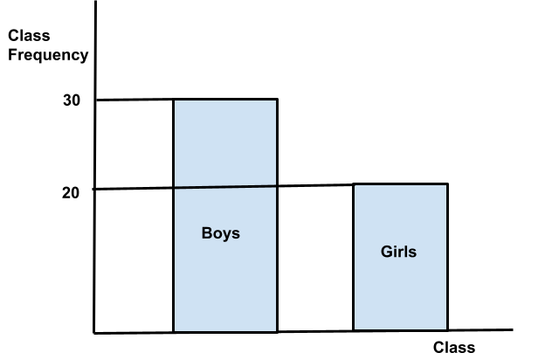

**Bar Graph Representation**

**Numerical column analysis :**

In this data we provide only numerical values.

Example: In a class of 5 boys and 5 girls got marks in an exam.

|  |  |  |  |  |
| --- | --- | --- | --- | --- |
| 5 | 8 | 10 | 13 | 17 |
| 18 | 19 | 21 | 24 | 26 |

For this numerical data we will draw a table and that table is known as Distribution table.

**Frequency Distribution Table :**

Distribution means : Data Flow

|  |  |
| --- | --- |
| Class Interval ( Interval ) | Interval Frequency ( Count ) |
| 0-5 | 1 |
| 5-10 | 2 |
| 10-15 | 1 |
| 15-20 | 3 |
| 20-25 | 3 |

If we seen any raw data in this type then we can conclude that the data is in Numerical column analysis.

For clear understanding of this raw data in numerical column analysis we will represent in Histogram.

**Histogram :**

* For any type of graph we need two axis.They are:
* X - axis : Class Interval
* Y - axis : Interval Frequency
* For Histogram it should be Numerical column vs Numerical column

